MobilityHub SaaS: A Smart Cloud Platform for Car Rental and Transport Operations

Capstone Project Presented to
The Faculty of the College of Computing & Information Sciences
Surigao del Norte State University
Surigao City

In Partial Fulfillment
Of the Requirements for the Degree
Bachelor of Science in Information Technology

By

Napoles, Rafael D.
Rivera, Akira Marialyn O.

May 2026
ABSTRACT
This study aimed at developing a Car Rental Management System for 4K's Car Rental, which operates in Surigao del Norte, and utilizes a manual process of doing things in the operations of car rental. The objectives of the study include the creation of computer-based solutions for the management of transactions and records and solving the problems that may be encountered when conducting activities manually. In general, some of the problems that the study focused on solving are inefficiencies, inaccurate records, and other common problems that come with manual systems.
This study applied a system development process involving planning, analysis, design, implementation, and testing. To identify the current problems faced by the business, data were collected using observations and interviews. Some of the identified needs of the business include the capacity of the computer-based solution to provide services for managing customers, managing vehicles, conducting rental, and creating reports. The outcomes of the study included faster transaction processing, efficient handling of record keeping, and more effective management of operations.
The implemented system provides customers with account registration that requires acceptance of the Terms and Conditions, vehicle browsing, a calendar showing booked and maintenance dates, booking requests with payment-proof uploads, current booking status, optional senior or PWD discount requests, and QR verification at pickup and return. The admin side supports vehicle and customer records, maintenance schedules, booking review and conflict resolution, discount checks, QR scans, and a dashboard with fleet and booking-status charts. These functions organize the rental workflow and records for customers and staff.

KEYWORDS
car rental management system, information system, rental transactions, surigao del norte, system development

1. INTRODUCTION
The persistent reliance on manual means in managing transactions and documentation in car rentals companies leads to inefficiency in the way businesses work, in data precision, and service delivery. The purpose of this research paper is to design a Computerized System for Car Rental that will increase the level of efficiency and preciseness in carrying out car rental transactions by the 4K’s Car Rental business. As we keep seeing advancements in technological innovations, all businesses are encouraged to embrace automated systems to ensure increased productivity and competitiveness in the industry.
Manual systems are associated with delays in the process of transaction processing, misplacing of important documents, and poor data management in record keeping. Such difficulties may result in disrupting business activities leading to poor management of the customers' information and rentals. Therefore, in this day and age of computerization, any business whose business relies on numerous transactions should consider designing a system that facilitates efficient data processing.
The proposed car rental management system will automate vital business functions including data entry, processing of customer and vehicle information, rental management and payments among others. Transition from manual business to computerized business will lead to reduction of inefficiencies, automation of processes, and easy transactions.
This study is important because it introduces a technological solution that can improve the performance of a local car rental business. In Surigao del Norte, where some businesses are still adapting to digital transformation, implementing such a system can enhance productivity, ensure data accuracy, and improve customer satisfaction. It also supports the modernization of small businesses, helping them cope with the demands of a technology-driven environment.
This research aims to answer the following questions: (1) What challenges are experienced in manual car rental transaction systems? (2) How can a computerized car rental management system improve efficiency and accuracy? (3) What features are essential for effectively managing rental operations and records? (4) How effective is the proposed system in terms of usability, reliability, and performance?

1.1 Project Context
Today, the world revolves very fast together with the rapid development and improvement of technology. Some of today's businesses are being controlled through the use of technology, with the help of technology the business process is accelerated and it also contributes to business growth. But yet there are few establishments that still use manual processes and one of these is the 4K’s Car Rental.
The 4K’s Car Rental began in January 2020 under the management of Mr. Arnelio O. Rivera. It is located in Barangay Ouano, Alegria, Surigao del Norte, and is the first car rental company established in the area. The company offers a convenient location for renting vehicles to accommodate customers.
But one of the problems that the 4K’s Car Rental encountered, their transaction is paper-based and it's badly consuming time. As a result, their business income is weak for the reason that they sometimes misfiled the records which slows the entire process.
The proponents design a rental system for 4K’s Car Rental to help them boost their business and manage all the transactions of their rental business in an efficient way With this idea, the system is capable of smoother and enhances the rental business.

1.2 Purpose and Description
The purpose of this study is to automate the current manual process and provide a platform for users and rental product owners in an effective and efficient manner.
This study aims to ease and simplify the staff work and replace the old method into a computerized way of renting a car. The system surely provides satisfaction and makes transactions faster and hassle free. In this project the proponents will have a smoother running and easy to use system to manage their daily transactions.

1.3 General Objectives of the Study
The main objective of this study is to design and develop a Car Rental Management System for Rivera’s Car Rental.
Specifically, the study aims to do the following:
1. To gather data and determine the system requirements
2. To design and develop the system
3. To test and evaluate the system’s functionality

1.4 Scope and Limitations
The implemented Vehicle Rental Management System provides separate customer and administrator interfaces. Customers can register after accepting the Terms and Conditions, browse vehicles and daily rates, check booked and scheduled-maintenance dates, submit a booking request with pickup date and time and payment proof, request an optional senior or PWD discount, review booking status, and present a booking QR code for pickup and return. Administrators can manage vehicle and customer records, set vehicle status and maintenance dates, review and decide booking requests, resolve maintenance conflicts by rescheduling, assigning another available car, or cancelling after contacting the customer, verify discounts and QR handovers, and monitor dashboard summaries. A customer-only Android application is also available. The system does not process payments or send automatic customer notifications.
Scope:
- The system supports customer registration with required Terms and Conditions acceptance, plus administrator login and logout.
- The customer landing page presents an overview of the system, About Us, Services, and Contact sections.
- Customers can browse vehicle details and daily rates and check availability in a calendar.
- The calendar marks booked and maintenance dates as unavailable for new bookings.
- Customers can submit pickup date and time, payment proof, and optional senior or PWD discount requests.
- Administrators can manage vehicle records, daily rates, and Available, Rented, or Under Maintenance status.
- Administrators can schedule maintenance and review, approve, deny, reschedule, reassign, or cancel affected booking requests.
- The admin side includes customer records, dashboard status charts, discount checks, and QR pickup and return verification.
Limitations:
- The system does not process payments online; customers upload proof of payment for administrator review.
- The system does not provide live GPS tracking or automatic SMS, email, or push notifications. Staff contact customers directly about maintenance changes, and conflict resolution is limited to bookings awaiting pickup.
- A booking request records pickup date and time but not a return date. Dashboard charts summarize activity rather than exporting detailed reports, and the Android application is for customers only.

2. REVIEW OF RELATED LITERATURE
The proponents gathered various local and foreign literature and studies in this chapter to review publications and investigations related to the proposed car rental system. This comprehensive review helps researchers understand existing approaches and develop a more advanced and effective car rental system.

FOREIGN
According to Ghritlahare, Jagat, Uikey, Pradhan, and Sahu (2021), an online car rental system was developed to simplify the process of finding and booking vehicles, allowing both customers and owners to manage transactions efficiently through a web-based platform. However, gaps remain in integrating real-time tracking features and ensuring the system is fully accessible across different types of mobile devices.

According to Aini (n.d.), the development of a car rental management information system helps organize data and improve business operations by automating records and rental processes. However, gaps remain in evaluating the system's security measures and its ability to handle large amounts of data without technical issues.

According to The Influence of Car Rental Product Quality, Prices, and Complaint Handling System (n.d.), factors such as product quality, pricing, and customer service significantly affect the decision to avail car rental services. However, gaps remain in determining how these factors specifically interact with each other and how they can be optimized together for better business outcomes.

According to Web-Based Car Rental Information System: Case Study CV Rafael Trans (n.d.), web-based systems provide an effective way to manage vehicle information and rental transactions in a centralized manner. However, gaps remain in conducting long-term studies on the system's maintenance requirements and its adaptability to changing business needs.

According to the Car Rental Management System (n.d.), automating reservations, billing, and fleet management leads to increased efficiency and better customer satisfaction in rental businesses. However, gaps remain in exploring the integration of advanced technologies like artificial intelligence to further improve recommendation features and predictive analysis.

According to [Title unknown] (n.d.), various technical frameworks and methodologies have been proposed to enhance the functionality of rental management platforms. However, gaps remain in testing these frameworks in actual local business environments and comparing their performance with existing systems.

According to [Title unknown] (n.d.), digital transformation in the transportation sector has shown positive results in terms of speed and accuracy of services. However, gaps remain in addressing the digital literacy of users and ensuring that these systems are user-friendly for all age groups.

According to [Title unknown] (n.d.), effective data management is crucial for the success of any online rental system to ensure reliability and smooth operation. However, gaps remain in developing standardized protocols that can be applied universally across different rental companies and regions.

LOCAL
According to Albino and Acebedo (2021), the development of a car rental management system with scheduling algorithm significantly improved transaction speed and inventory organization, making operations easier and more reliable for both staff and customers. However, gaps remain in integrating advanced features such as real-time vehicle tracking and automated payment systems which could further enhance service efficiency.

According to Abat, Buen, and Giron (2023), an online car rental system was found to be highly acceptable in terms of functionality, usability, and security, proving that web-based solutions are effective in simplifying rental transactions. However, gaps remain in assessing the system's long-term durability and its ability to handle large volumes of concurrent users during peak seasons.

According to Golo and Encarnacion (2024), revolutionizing rental services through online systems addresses the growing demand for convenient transportation solutions in tourist areas like Siargao Island. However, gaps remain in addressing internet connectivity issues and ensuring that such systems are accessible to users with limited technical knowledge.

According to APC Car Rental Management System with GPS Vehicle Tracking (n.d.), integrating GPS technology allows business owners to monitor vehicle location and status in real-time, which greatly improves security and fleet management. However, gaps remain in the cost-effectiveness of such systems and their compatibility with older hardware or mobile devices.

According to Diamond Rent-A-Car Vehicle Booking and Management System (n.d.), automated booking and record-keeping eliminate manual errors and reduce the time spent on administrative tasks. However, gaps remain in providing multi-language support and integrating mobile application features that allow customers to book directly from their phones.

According to studies available on arXiv (n.d.), various algorithms and technical frameworks have been proposed to optimize reservation systems and data management. However, gaps remain in testing these theoretical models in actual business environments and adapting them to the specific needs of local car rental industries.

3. TECHNICAL BACKGROUND
This chapter describes the implemented 4Kâ€™s Car Rental Management System. It supports account access, vehicle and customer records, date-based availability, booking review, and pickup and return tracking through a shared application database. The User Side provides customer-facing booking functions, while the Admin Side provides tools for vehicle schedules and rental operations.
The system has two role-specific interfaces: a customer User Side and an Admin Side for authorized staff. A customer-only Android application provides access to the User Side; administrators use the web-based Admin Side.
The system uses Laravel and PHP for server-side processing and authenticated API routes, Vue.js and JavaScript for interactive interfaces, and HTML and CSS for page structure and styling. Vite builds the web assets, and Capacitor packages the customer interface for Android. Application records are stored in a relational database.
The Admin Side allows authorized staff to review dashboard summaries, manage vehicles and customer records, update vehicle rates and status, schedule maintenance, review proof of payment, approve or deny requests, resolve eligible maintenance conflicts, verify discount claims, and scan booking QR codes at pickup and return. An admin logout control is available in the navigation bar.
The User Side lets customers register and sign in, read and accept the Terms and Conditions, browse vehicle details and rates, check booked and maintenance dates, submit booking requests with pickup time and payment proof, request an optional discount, and view booking status and QR details. The login landing page also includes system overview, About Us, Services, and Contact sections.
The database stores customer account and profile details, acceptance of the Terms and Conditions, vehicle information and rates, maintenance dates, booking requests, payment-proof file references, discount status, and pickup or return verification timestamps. These records support the functions shared by the User Side and Admin Side.
The system does not include live vehicle location tracking, an online payment gateway, automatic SMS or email notifications, or detailed report exports. It records a pickup date and time but not a return date. The Android application serves customers only; administrators use the web interface. Staff must contact customers directly when a maintenance conflict requires an agreed booking change.
3.1 CONCEPTUAL FRAMEWORK
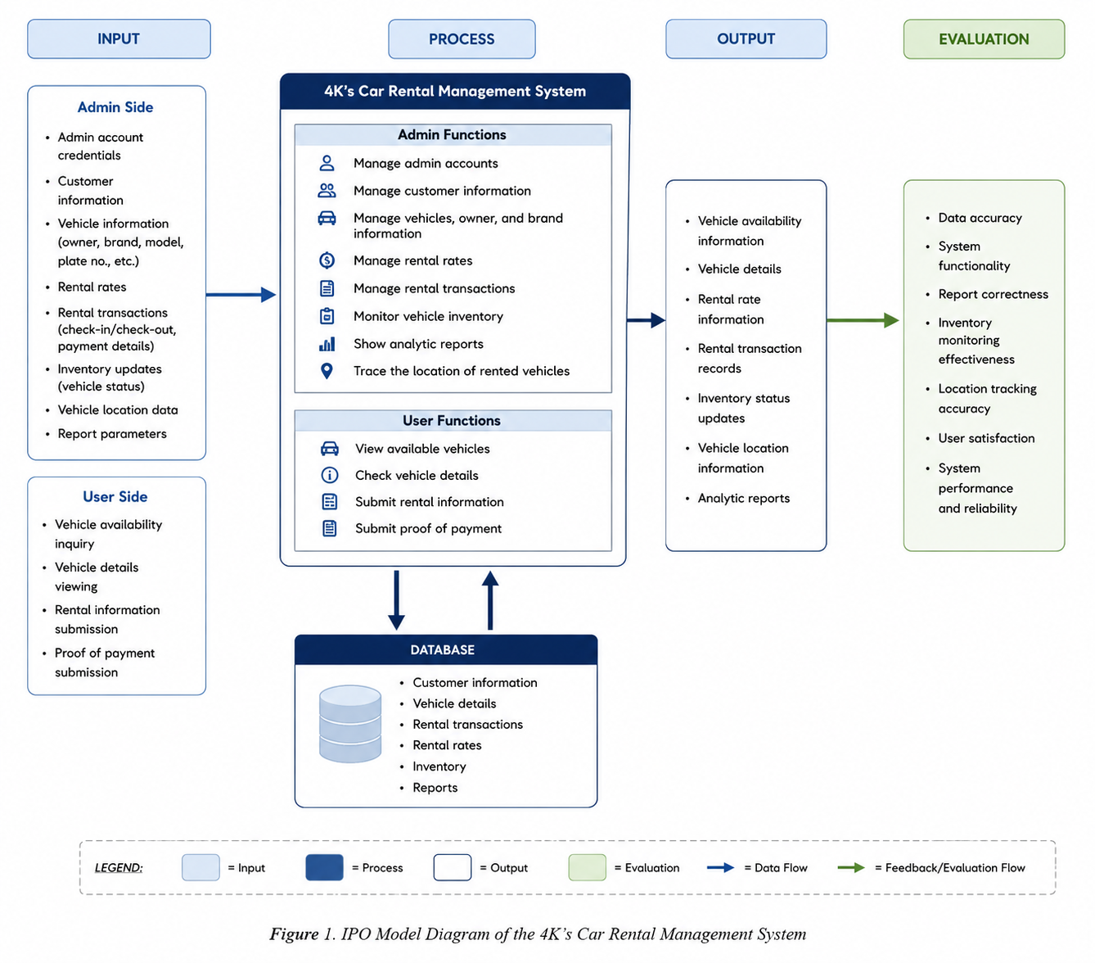
Figure 1. Conceptual Framework of 4K’s Car Rental Management System
The IPO (Input-Process-Output) Model Diagram of the proposed 4K’s Car Rental Management System illustrates how data is entered, processed, stored, and transformed into useful information within the system. The diagram also includes an evaluation component to assess the effectiveness and reliability of the system.
The Input section includes customer account details and Terms and Conditions acceptance, vehicle availability requests, pickup date and time, optional discount requests, and uploaded payment proof. Administrator inputs include vehicle records and rates, vehicle status, maintenance dates, booking decisions, discount verification, and QR scans for pickup and return.
The Process section represents account validation, vehicle and customer record management, calendar-based availability checks, booking submission, and administrator review. The system prevents new requests for booked or maintenance dates. Administrators can approve or deny requests, resolve eligible maintenance conflicts by rescheduling or assigning another available car, verify discount claims, and record pickup or return after scanning the booking QR code.
The Database stores customer and vehicle records, daily rates and status, maintenance schedules, booking dates and decisions, payment-proof references, discount review results, and QR pickup or return timestamps. It supports the User Side and Admin Side functions described in this framework.
The Output section includes vehicle and rate information, calendar availability, booking records and status, payment-proof records, discount decisions, pickup and return verification, customer records, and dashboard summaries with fleet and booking-status charts. It does not include vehicle location data or detailed report exports.
The Evaluation section measures functionality, usability, reliability, security, performance, record accuracy, availability checks, and user satisfaction. Evaluation does not include live location tracking, because that feature is not part of the implemented system.

4. METHODOLOGY
This chapter presents the methodology used in the development of the proposed 4K’s Car Rental Management System. It explains the processes, techniques, and tools used by the proponents in developing the system. The chapter includes the software development methodology, planning requirements, prototype creation, feedback gathering, software finalization, and evaluation methods and tools used in the study.
The proponents used the Rapid Application Development (RAD) methodology in developing the proposed system. RAD is a software development approach that focuses on fast development, continuous testing, and repeated improvement based on user feedback. This methodology is suitable for the study because the proponents continuously tested and updated the system during development until the desired output and functionalities were achieved.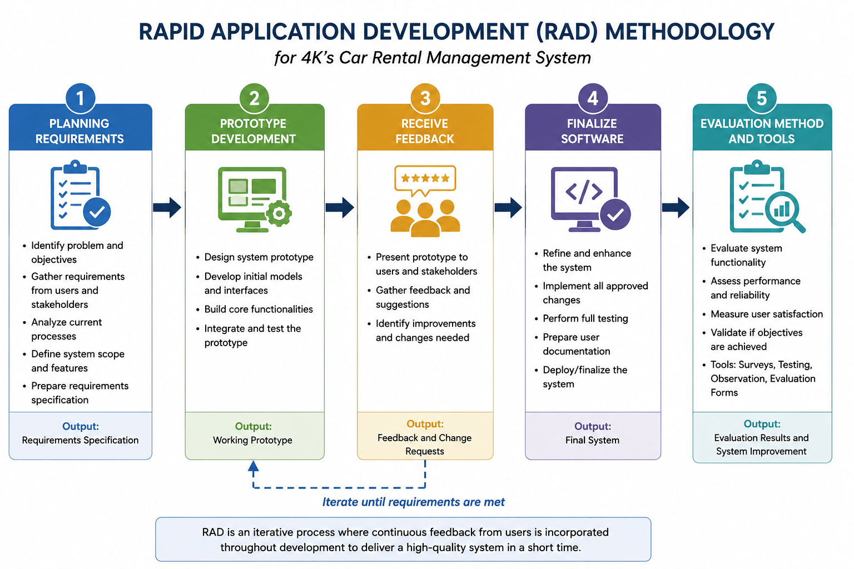
The RAD methodology helped the proponents quickly identify problems, improve system features, and make changes based on the suggestions of users and stakeholders. Through this process, the proposed system became more efficient, user-friendly, and aligned with the needs of 4K’s Car Rental.
The phases used in the study include:
- Planning Requirements
- Prototype Development
- Receive Feedback
- Finalize Software
- Evaluation Method and Tools
4.1 Planning Requirements
In this phase, the proponents gathered the necessary information and requirements needed for the development of the proposed system. Interviews and observations were conducted with the owner and staff of 4K’s Car Rental located in Alegria, Surigao del Norte. The purpose of this phase was to identify the problems encountered in the current manual process and determine the needed features of the computerized system.
Based on the gathered information, the proponents identified several problems in the existing manual system such as time-consuming transactions, misplaced records, difficulty in monitoring vehicle availability, and inaccurate record management. These problems affect the daily operation and efficiency of the business.
The proponents also identified the functional and non-functional requirements of the system. Functional requirements refer to the features and functions that the system must perform, while non-functional requirements refer to the quality and performance of the system.
The identified functional requirements include:
- Customer registration and login with Terms and Conditions acceptance
- Administrator authentication and logout
- Vehicle and customer record management
- Vehicle daily-rate and status management, including Under Maintenance
- Availability calendars that mark booked and maintenance dates
- Booking requests with pickup date and time and payment-proof upload
- Booking approval or denial and maintenance-conflict resolution
- Optional discount review, pickup and return QR verification, and dashboard summaries
The identified non-functional requirements include:
- Consistent white-and-blue interface with light and dark themes
- Responsive customer web and Android interfaces, with admin access on the web
- Protected customer and administrator access to role-specific functions
- Clear availability states and server-side validation of booking dates
- Understandable navigation, forms, and booking-status feedback
After gathering all the requirements, the proponents analyzed the data and used it as the basis for designing and developing the proposed 4K’s Car Rental Management System.
4.2 Prototype
User Side:
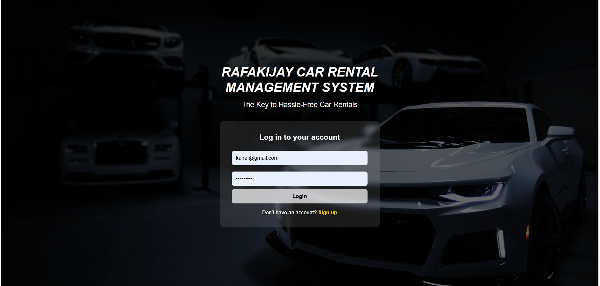
Figure 2. User Login Page
Figure 2 shows the customer login page and landing experience. Alongside account sign-in, the page presents a system overview, About Us, Services, and Contact sections, with a light and dark theme toggle.

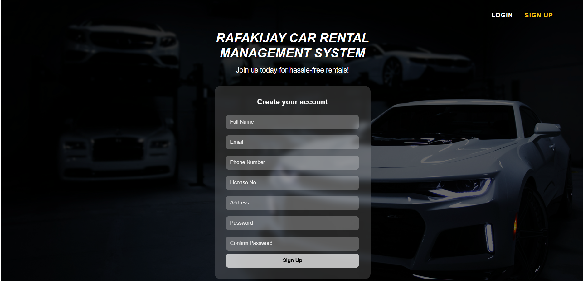
Figure 3. User Signup Page
Figure 3 presents the customer signup page. In addition to personal and account details, the form requires users to check their agreement to the clickable Terms and Conditions before the server accepts account creation.
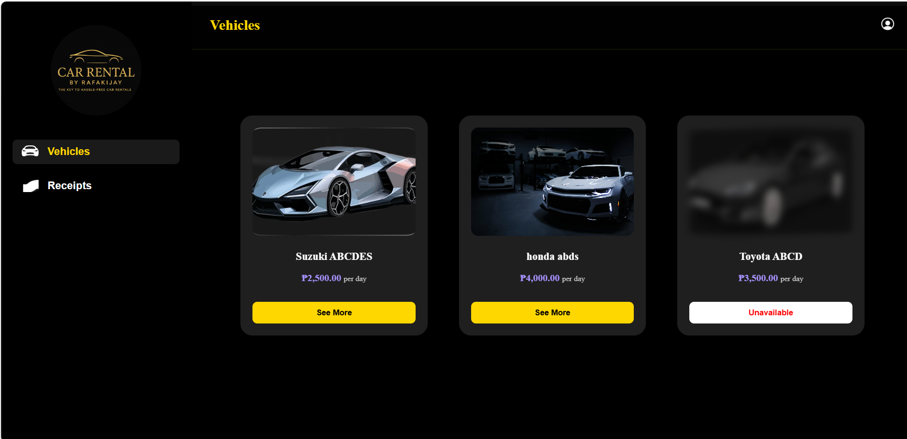
Figure 4. User Vehicles Page
Figure 4 shows the customer vehicle page, where users can review vehicle details and daily rates. The booking form includes an availability calendar that marks booked and maintenance dates, pickup time, payment-proof upload, and an optional senior or PWD discount request.
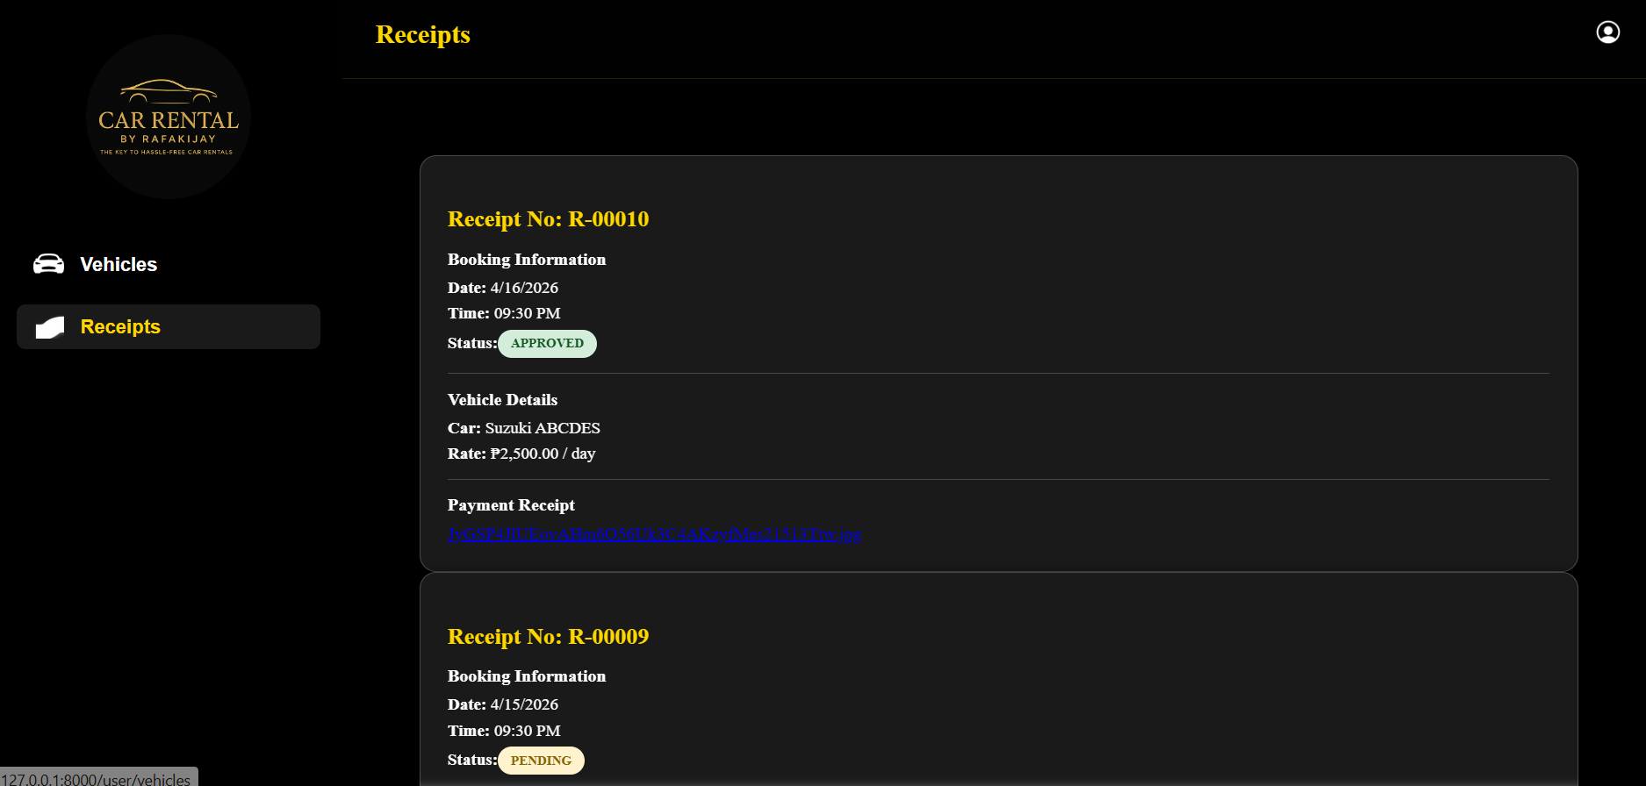
Figure 5. User Receipts Page
Figure 5 presents the customer bookings and receipts page. It displays booking details and current approval status, payment-proof information, optional discount status, and the booking QR code used for pickup and return verification.

Admin Side:
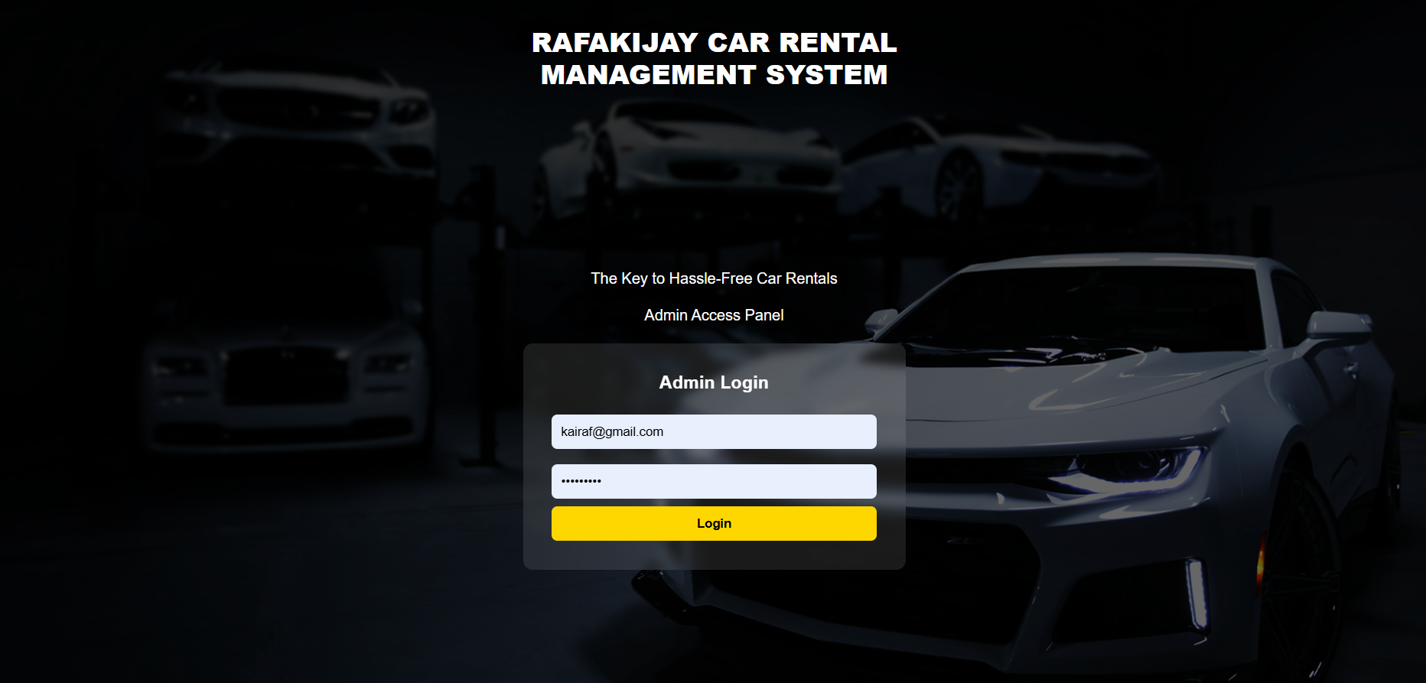
Figure 6. Admin Login Page
Figure 6 shows the admin login page of the 4K’s Car Rental Management System. This page is intended for authorized personnel only, allowing the admin to access the system by entering the correct email and password. It helps protect the system from unauthorized access.
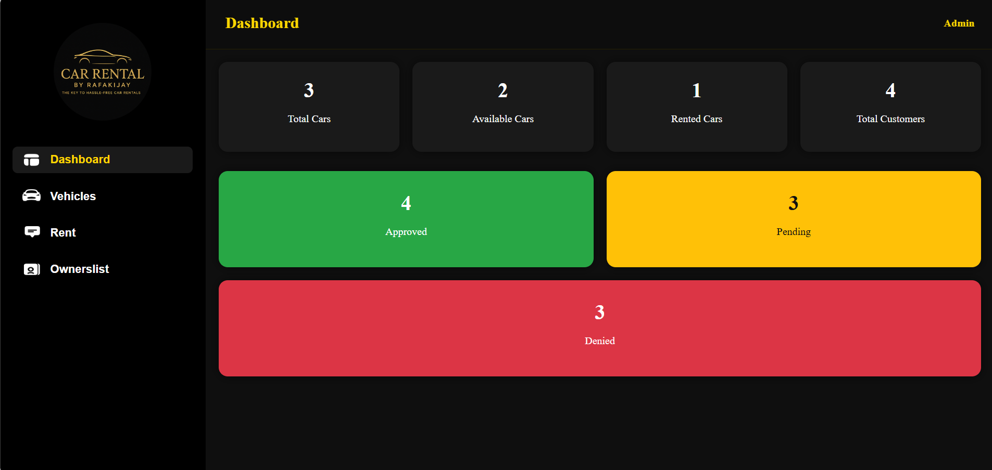
Figure 7. Admin Dashboard Page
Figure 7 presents the admin dashboard with total, available, and rented vehicle counts, total customers, and pending, approved, and denied booking counts. Circular ring charts visualize fleet availability and booking status.
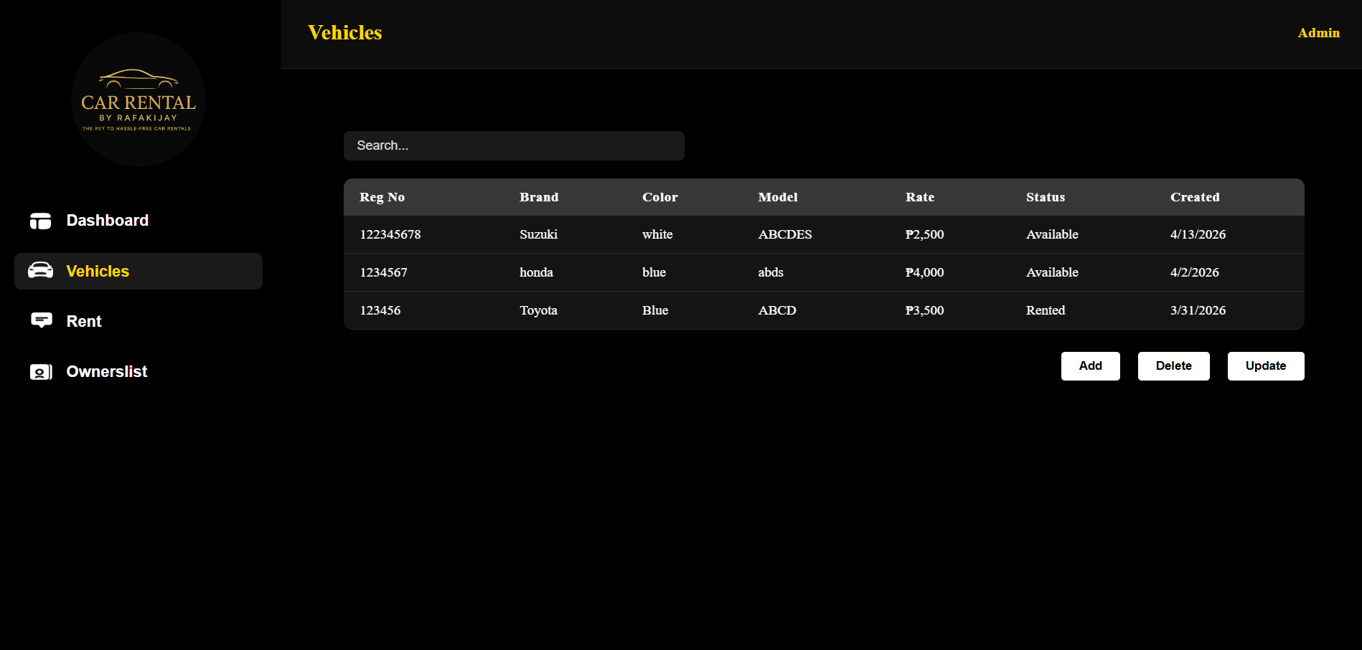
Figure 8. Admin Vehicles Page
Figure 8 shows the admin vehicles page, which supports adding, updating, and deleting vehicle records and changing each vehicleâ€™s daily rate and status. The update form includes an availability calendar for scheduling or removing maintenance dates.
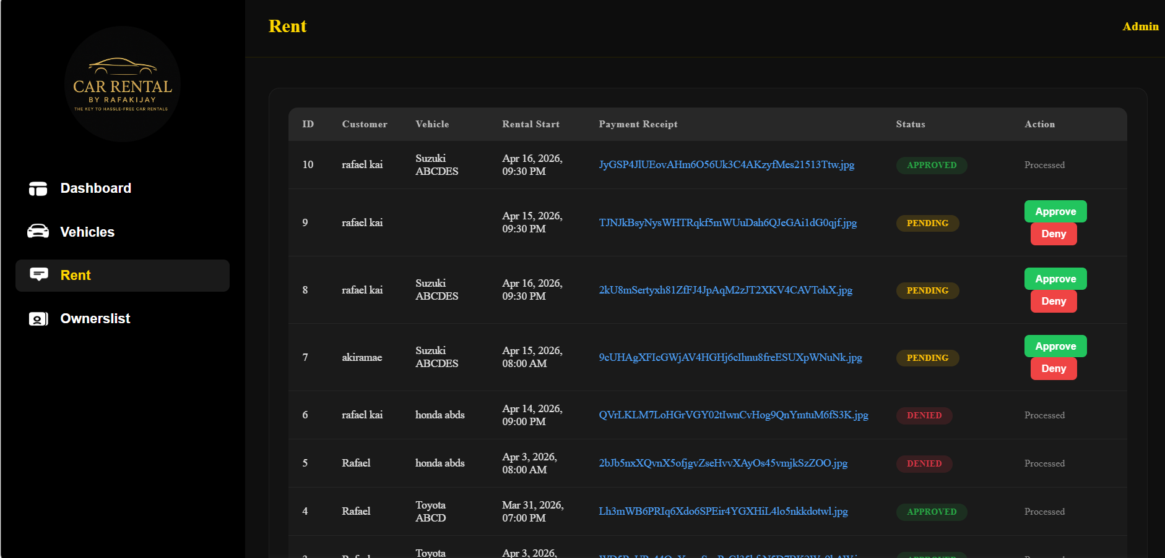
Figure 9. Admin Rent Page
Figure 9 presents the admin rental requests page. Staff can review booking details and payment proof, approve or deny requests, review discount claims, scan pickup and return QR codes, and resolve maintenance conflicts by rescheduling, assigning another available vehicle, or cancelling after notifying the customer.
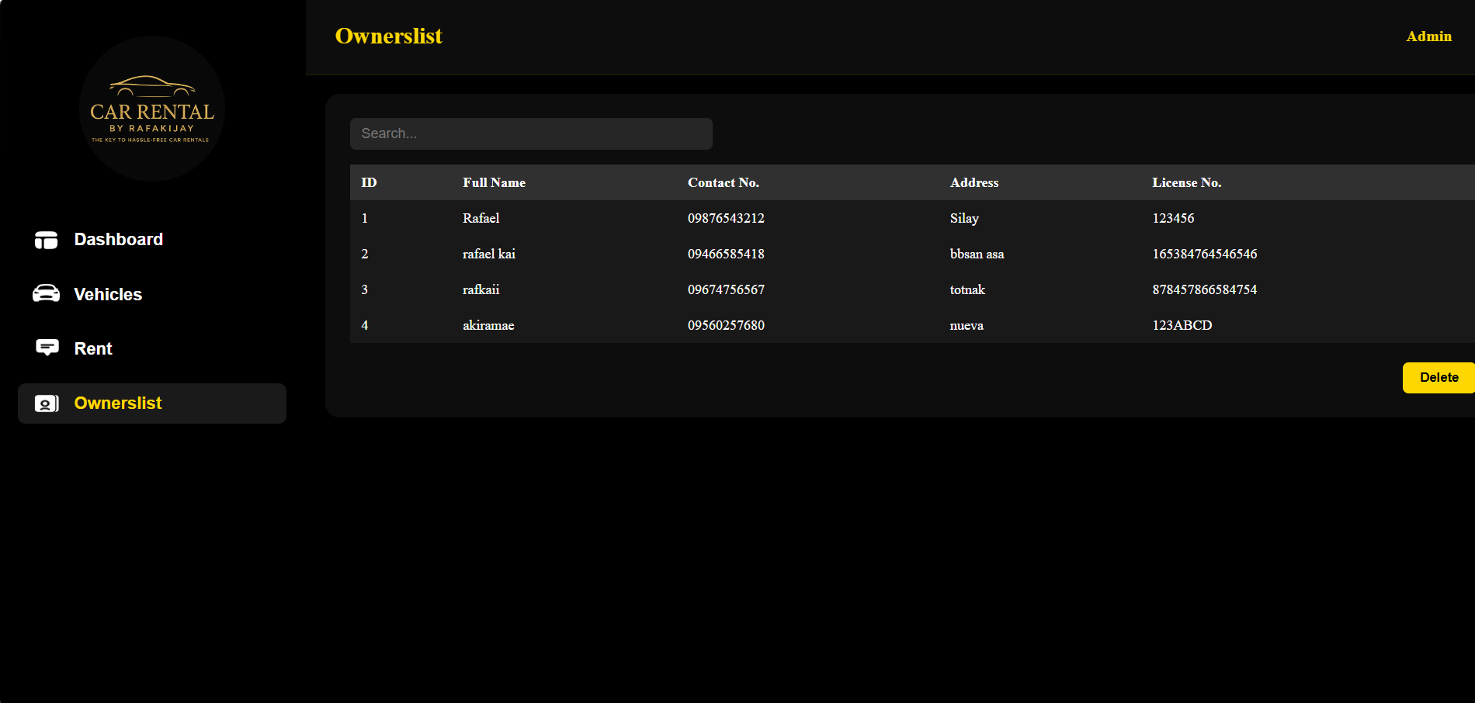
Figure 10. Admin Customer Records Page
Figure 10 shows the admin customer records page, which lists registered customer names, contact details, addresses, and license information and provides search and delete actions.
After identifying the system requirements, the proponents created a prototype of the proposed 4K’s Car Rental Management System. The prototype served as the initial visual design of the system, showing the possible appearance, layout, and basic functions before the actual development process.
The current interfaces use a consistent white-and-blue visual theme with a light and dark mode control on both customer and admin pages. Navigation and forms are organized around each roleâ€™s tasks, including vehicle browsing and booking for customers and fleet and request management for staff.
For the User Side, the implemented pages include a login landing page with system overview and contact information, signup with required Terms and Conditions acceptance, a vehicle list with date-based availability, a booking request form, and a bookings page showing status, discount review, payment-proof details, and QR verification.
For the Admin Side, the implemented pages include admin login, a dashboard with ring charts, vehicle and customer record management, maintenance scheduling, and rental request review. Staff can approve or deny requests, resolve maintenance conflicts, verify discounts, scan pickup and return QR codes, and log out from the admin navigation.
The proponents used wireframes and layout designs to organize the placement of buttons, forms, tables, images, and navigation menus. During this phase, the proponents ensured that the design matched the needs of both customers and authorized personnel.
Overall, the prototype helped the proponents visualize the flow of the system and identify possible improvements before the actual coding and implementation process. It served as a guide for developing a more organized, functional, and user-friendly car rental management system.
4.3 Receive Feedback
After creating the prototype, the proponents presented it to the owner and selected users of 4K’s Car Rental for evaluation and feedback. The purpose of this phase was to gather suggestions, comments, and recommendations that could improve the system design and functionality.
The stakeholders reviewed the prototype and provided feedback regarding the layout, navigation, and system features. Some of the suggestions gathered include:
- Improving the arrangement of buttons and menus
- Adding clearer vehicle availability indicators
- Improving report generation features
- Making the transaction process easier and faster
The proponents carefully analyzed all suggestions and identified which improvements should be added to the system. The feedback received became the basis for revising and enhancing the design and functionalities of the proposed system.
Through continuous feedback and revisions, the proponents improved the usability and efficiency of the system. This process also ensured that the developed system met the needs and expectations of the business owner and users.

4.4 Finalize Software
After the revision of the prototype, the proponents proceeded with the actual development and implementation of the proposed 4K’s Car Rental Management System. The final version of the software was developed using web development technologies and database management tools.
The implemented system uses the following technologies:
- HTML for page structure
- CSS for interface styling and light or dark themes
- JavaScript and Vue.js for interactive customer and admin interfaces
- PHP with Laravel for backend processing and API routes
- A relational database for customer, vehicle, maintenance, and booking records
The implemented system includes the following modules:
- Customer account registration, login, and Terms and Conditions acceptance
- Administrator login and logout
- Vehicle inventory, customer records, and daily-rate management
- Vehicle status and maintenance scheduling with availability calendars
- Booking requests with pickup date and time, payment proof, and optional discounts
- Booking approval or denial and maintenance-conflict resolution
- Discount verification and QR pickup or return records
- Fleet and booking-status dashboard charts, shared light and dark themes, and a customer-only Android application
During this phase, the proponents conducted system testing to ensure that all functions worked properly. Different tests were performed such as functionality testing, usability testing, and error checking. The system was tested repeatedly to identify bugs, errors, and technical problems.
The proponents also improved the system based on the results of testing and feedback gathered from users. Necessary adjustments were made to improve system performance, reliability, and usability.
The final version of the proposed system was successfully developed and prepared for evaluation and implementation at 4K’s Car Rental.
4.5 Evaluation Method and Tools
To evaluate the effectiveness and performance of the proposed 4K’s Car Rental Management System, the proponents used the ISO 25010 Software Quality Model. This evaluation model is commonly used in measuring the quality and performance of software systems.
The evaluation focused on the following criteria:
- Functionality
- Usability
- Reliability
- Performance Efficiency
- Security
The proponents conducted usability testing and system evaluation with selected respondents composed of the business owner, staff members, and selected users. Questionnaires and feedback forms were distributed to gather their evaluation and opinions regarding the system.
The evaluation tools used in the study include:
- Survey questionnaires
- User feedback forms
- Observation during system testing
- Functionality testing
- Error checking and debugging
The respondents evaluated the system based on:
- Ease of use
- Accuracy of information
- Speed of transaction processing
- Reliability of the system
- User satisfaction
The proponents analyzed the collected data to determine whether the proposed system successfully met the objectives of the study. The evaluation results showed that the proposed system improved the efficiency of rental transactions, reduced manual workload, organized records properly, and enhanced the overall operations of 4K’s Car Rental.
Therefore, the proposed 4K’s Car Rental Management System was considered effective and beneficial for the business operations of 4K’s Car Rental.

5. RESULTS AND DISCUSSIONS
This chapter presents the implemented 4Kâ€™s Car Rental Management System and its current User Side and Admin Side functions. It describes how account access, vehicle availability, booking requests, maintenance schedules, payment-proof review, and pickup or return verification are handled in the system.
The implemented system manages customer records, vehicle information, daily rates and status, maintenance dates, booking requests, payment-proof references, optional discount claims, booking decisions, and QR pickup or return verification. The admin dashboard summarizes vehicle availability and booking statuses, while the customer side provides browsing, booking, and status review.
The system has two main interfaces. The Admin Side manages vehicle and customer records, maintenance schedules, booking decisions, discount verification, QR handovers, and dashboard summaries. The User Side lets customers create an account under the Terms and Conditions, browse vehicles, check date availability, submit a booking request with payment proof, and review its status.
5.1 Project Planning
Project planning is an important phase in system development because it serves as the guide for completing the proposed system within the planned schedule and resources. In this study, the proponents prepared a timeline and organized the activities needed for the development of the 4K’s Car Rental Management System.
The project planning included requirement gathering, system analysis, prototype design, coding, testing, revision, evaluation, and documentation. The proponents divided the tasks equally to ensure that the development process would be completed efficiently.
The project was developed using the Rapid Application Development (RAD) methodology, which allowed continuous testing and improvement during development. The proponents created schedules for each activity and monitored the progress of the project regularly.
The resources used in the development of the system included:
- Laptop or desktop computers
- Internet connection
- Development software and tools
- Database management software
- Reference materials and documents
The proponents also prepared a Gantt Chart to present the schedule and duration of the activities involved in the development process.
The project planning helped the proponents complete the system in an organized and systematic manner.
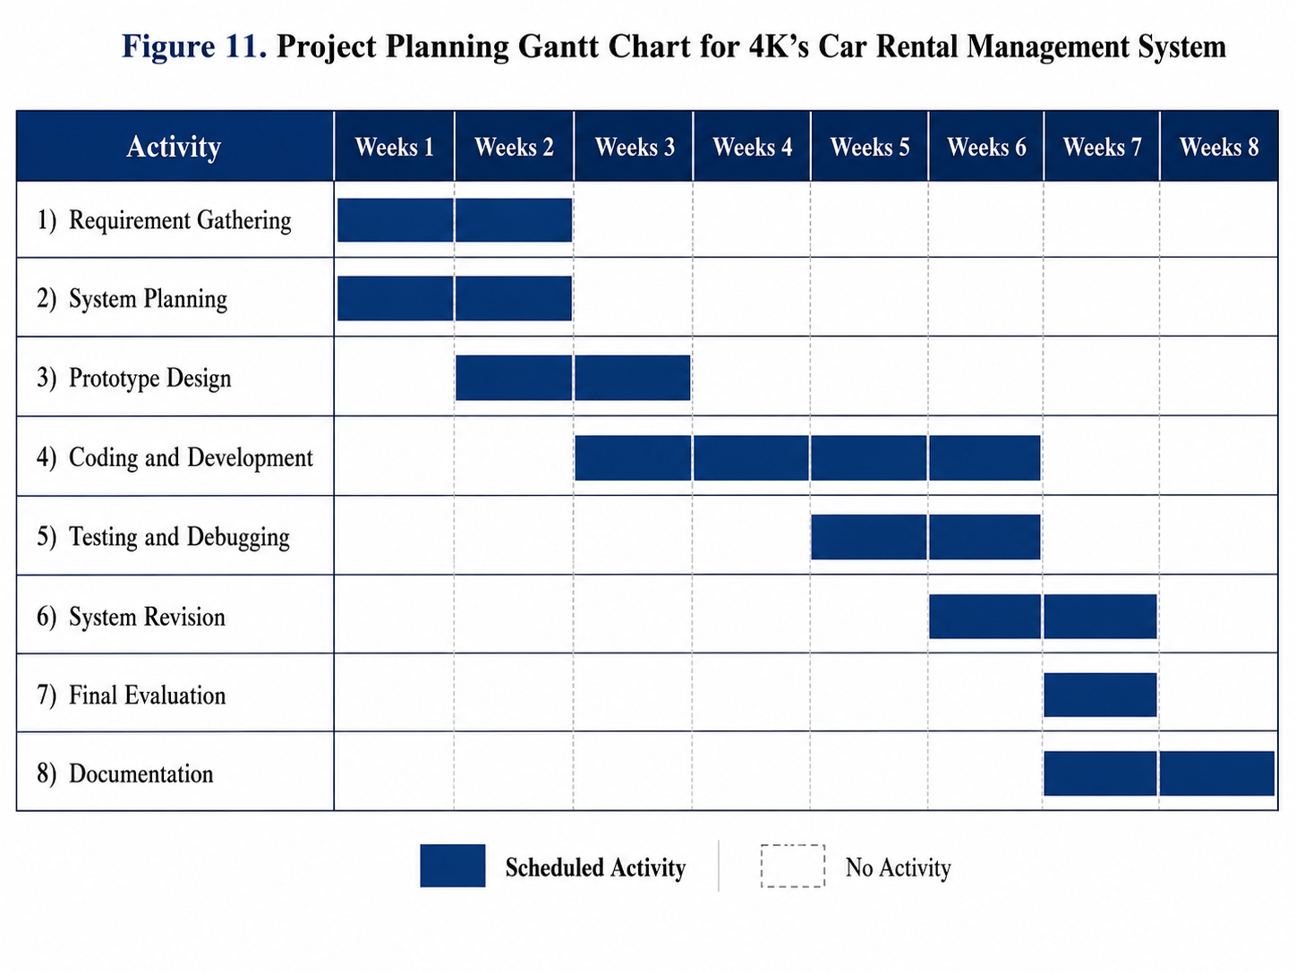

5.2 System Design
The system design presents the structure and flow of the proposed 4K’s Car Rental Management System. Different diagrams were used to illustrate how the system operates and how users interact with it. These diagrams helped the proponents organize the functionalities, data flow, and processes of the system before the implementation phase.
The system design includes the Use-Case Diagram, Class Diagram, and Sequence Diagram.
a.) Use-Case Diagram
The Use-Case Diagram illustrates the current interactions between customers and administrators and the functions available to each role.
Administrators authenticate to manage vehicles and customer records, rates and status, maintenance schedules, booking requests, discount claims, QR handovers, and dashboard summaries. Customers register and accept the Terms and Conditions, browse vehicles, check booked and maintenance dates, submit requests, and review booking status.
The Use-Case Diagram includes these current functions:
- Register, accept the Terms and Conditions, and log in
- View vehicle details and daily rates
- Check booked and maintenance dates
- Submit a booking request and payment proof
- Review booking status and present a pickup or return QR code
- Manage vehicle and customer records
- Review, approve, or deny booking requests and resolve maintenance conflicts
- Verify discounts, scan pickup and return QR codes, and review dashboard summaries
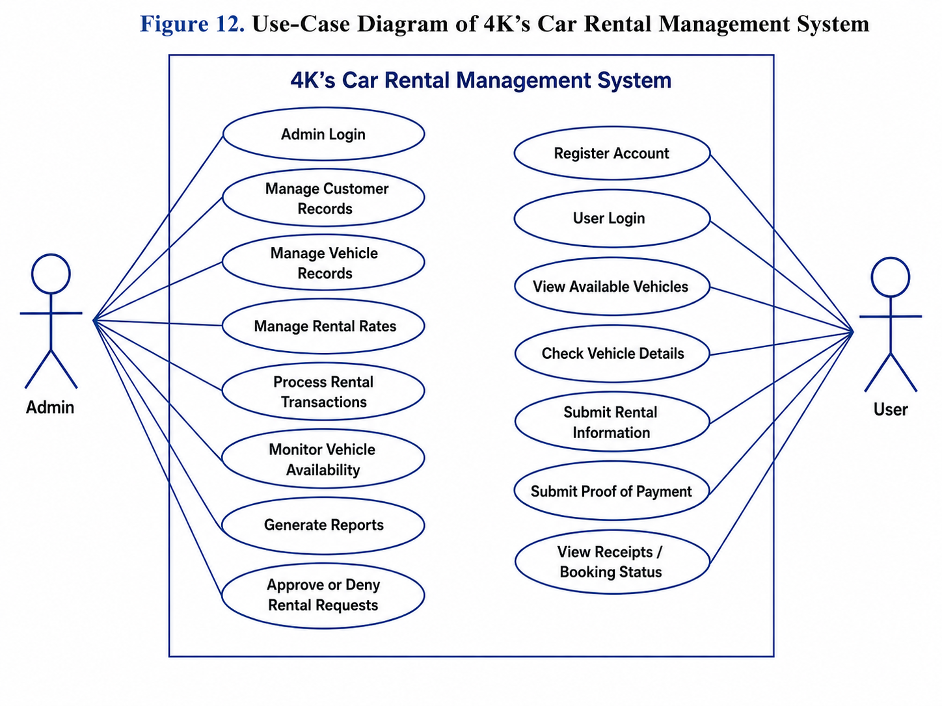
The diagram helped the proponents understand the responsibilities of each user and the functions available in the system.
The Use-Case Diagram also showed the relationship between the users and the system processes, making it easier to identify the necessary functionalities needed in the development of the proposed system.
b.) Class Diagram
The Class Diagram presents the structure of the database and the relationship between the data entities used in the proposed system. It shows the classes, attributes, and relationships involved in the Car Rental Management System.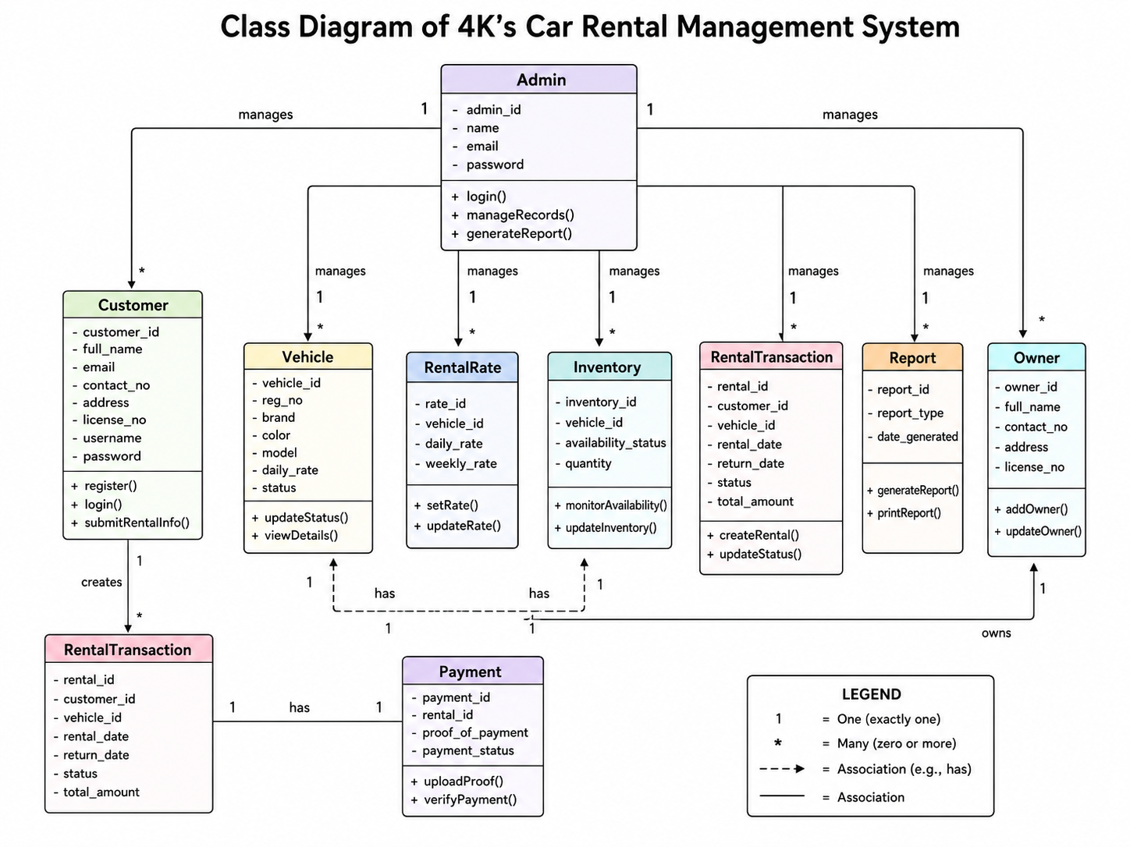
Each class contains important information needed by the system. For example, the Customer class contains customer details such as name, email, contact number, license no., and address, while the Vehicle class contains vehicle information such as registration no., brand, color, model, rate, and availability status.
The relationships between the classes help the system organize and manage information efficiently. The Class Diagram also serves as the guide for designing the database structure of the proposed system.

c.) Sequence Diagram
The Sequence Diagram shows the implemented rental flow from customer registration and availability checking through administrator review, booking decisions, and pickup or return verification. It also shows how the administrator handles a maintenance conflict affecting a booking that has not reached pickup.
A customer registers and accepts the Terms and Conditions or signs in, then browses vehicle details and daily rates. The customer checks the vehicleâ€™s calendar, selects an available pickup date and time, optionally requests a senior or PWD discount, and submits a booking request with payment proof.
The system records the request as pending. An administrator reviews the vehicle, requested pickup time, and payment proof and then approves or denies the request. The customer can view the booking status and details from the customer side.
The current sequence of the system flow is as follows:
- The customer registers and accepts the Terms and Conditions or logs in to an existing account.
- The system validates the account details and authorizes the customer.
- The customer browses vehicle details and daily rates.
- The system displays vehicle availability, booked dates, and maintenance dates in the calendar.
- The customer selects an available pickup date and time and may request a senior or PWD discount.
- The customer uploads payment proof and submits the booking request.
- The system validates the selected date against bookings and maintenance schedules.
- The system stores the request as pending with its pickup time, payment-proof reference, and discount status.
- The administrator signs in and reviews the request and uploaded proof.
- The administrator approves or denies a request when the vehicle and date are available.
- If maintenance conflicts with an uncollected booking, the administrator contacts the customer to discuss a new date, an available replacement car, or cancellation.
- After the customer agrees to a change, the administrator reschedules or reassigns the booking and the system checks the new date and vehicle.
- If the customer does not accept a change, the administrator confirms notification and cancels the affected booking.
- For an approved booking, the customer presents the QR code at pickup and return; the administrator scans it, records each handover, and reviews any discount ID at pickup.
The sequence reflects the current workflow: date and maintenance checks precede booking decisions, customer agreement is required for a maintenance-related change, and QR scans record vehicle pickup and return.

5.3 System Implementation
The implementation phase integrated the customer and administrator interfaces with the backend and database. The completed system includes date-based availability, booking review, maintenance scheduling, payment-proof records, discount checks, and QR handover verification.
The system uses the following technologies:
- HTML for page structure
- CSS for interface design, responsive layouts, and light or dark themes
- JavaScript and Vue.js for interactive customer and administrator pages
- PHP with Laravel for backend processing and API routes
- A relational database for customer, vehicle, maintenance, and booking records
The implemented system has two main interfaces:
- Admin Side
- User Side
The Admin Side allows authorized staff to:
- Review fleet, customer, and booking summaries in the dashboard
- Manage vehicle records, daily rates, vehicle status, and maintenance dates
- Review booking requests and payment proof, then approve or deny requests
- Resolve eligible maintenance conflicts and review discount claims
- Scan booking QR codes to record pickup and return
The User Side allows customers to:
- Register or sign in after accepting the Terms and Conditions
- Browse vehicles and check booked and maintenance dates
- Submit booking details and payment proof, request an optional discount, and review booking status and QR information
The proponents conducted several tests during implementation to ensure that the system functions properly. Errors and bugs identified during testing were corrected immediately to improve the performance and reliability of the system.
The interface figures in this chapter illustrate the principal customer and administrator pages, including login, dashboard, vehicle management, booking review, maintenance scheduling, and customer records.
The implementation of the proposed system successfully improved the management of records and rental transactions of 4K’s Car Rental.

5.4 Evaluation of the System
The customer User Side is available through a dedicated Android application. The application provides customer functions only; administrators use the separate web-based Admin Side.
The proponents used the ISO 25010 Software Quality Model as the basis for evaluating the system. The evaluation focused on the following criteria:
- Functionality
- Usability
- Reliability
- Performance Efficiency
- Security
Survey questionnaires and feedback forms were distributed to gather the opinions and suggestions of the respondents. The respondents evaluated the system based on:
- Ease of use
- Accuracy of records
- Speed of transactions
- User satisfaction
- Reliability of the system
Based on the evaluation results, the respondents found the system easy to use and effective in managing rental transactions and records. The computerized process reduced delays, minimized errors, and improved the organization of information.
The results also showed that the system improved transaction processing speed and made monitoring of vehicles and customer records more efficient.
Overall, the evaluation confirmed that the proposed system successfully met the objectives of the study and provided benefits to the operations of 4K’s Car Rental.

5.5 Android Mobile Application
The proposed 4K’s Car Rental Management System may also be accessed through an Android mobile application or mobile-friendly interface to provide more convenience for users and administrators.
Through the Android application, customers can:
- Create an account, accept the Terms and Conditions, and sign in
- Browse vehicle details, daily rates, and availability dates
- Submit a booking request with pickup time, payment proof, and an optional discount request
- Review booking status, payment-proof details, and pickup or return QR information
The Android application does not include administrator tools such as vehicle updates, maintenance scheduling, request decisions, customer records, or QR scanning; these remain in the web-based Admin Side.
The customer application uses the same account, vehicle, calendar, and booking functions as the customer web interface and includes the shared light and dark theme control.
The Android flow begins when a customer opens the application and registers or signs in. The customer browses vehicles, checks the availability calendar, submits a booking request, and later reviews its status.
Customers need an internet connection to reach the system and submit or review booking information from the Android application.
The Android application extends customer access to the User Side on a phone while keeping administrator operations in the web interface.

REFERENCES
International Journal of Advanced Research in Computer and Communication Engineering (IJARCCE). (2021). Car Rental Management System. Retrieved from
IJARCCE Research Paper
International Journal of Scientific Development and Research (IJSDR). (2021). Car Rental Management System. Retrieved from
IJSDR Research Paper
International Journal of Creative Research Thoughts (IJCRT). (2024). Car Rental Management System Study. Retrieved from
IJCRT Research Paper
International Journal of Novel Research and Development (IJNRD). (2024). Vehicle Rental Management Research. Retrieved from
IJNRD Research Paper 2024
Journal of Emerging Technologies and Innovative Research (JETIR). (2024). Car Rental Management System. Retrieved from
JETIR Research Paper
International Journal of Novel Research and Development (IJNRD). (2023). Development of Car Rental System. Retrieved from
IJNRD Research Paper 2023
Aini, Q. (2022). Development of Car Rental Management Information System. Retrieved from
Car Rental Management Information System Study
ResearchGate. (2024). The Influence of Car Rental Product Quality, Prices, and Complaint Handling System on Decisions to Use Car Rental Services at Botana Transport Rent Car Tour & Travel. Retrieved from
ResearchGate Study on Car Rental Services
International Journal of Advance Research and Innovative Ideas in Education (IJARIIE). (2024). Car Rental Management System. Retrieved from
IJARIIE Research Paper
International Journal of Engineering Sciences (IJES). (2024). Web-Based Car Rental System Study. Retrieved from
IJES Car Rental Study
ResearchGate. (2025). Web-Based Car Rental Information System: Case Study CV Rafael Trans. Retrieved from
ResearchGate Web-Based Car Rental Information System
Universitas Teknologi Yogyakarta Repository. (2024). Car Rental Information System Research. Retrieved from
UTY Repository Research
INFORMS Journal. (1997). Operations and Management Study Related to Rental Services. Retrieved from
INFORMS Research Article
Universitas Muhammadiyah Surakarta Repository. (2016). Car Rental Information System Study. Retrieved from
UMS Repository Research
MDPI. (2024). Research on Smart Transportation and Rental Systems. Retrieved from
MDPI Smart Transportation Study
Nusa Putra University Repository. (2023). Vehicle Rental Information System Development. Retrieved from
Nusa Putra Repository Research
Jaypee University Repository. (2023). Car Rental Management System Research Project. Retrieved from
Jaypee University Research
Science World Journal. (2024). Transportation and Vehicle Rental System Study. Retrieved from
Science World Journal Article

Local References
ResearchGate. (2024). Revolutionizing the Rental Services in Siargao Island: Basis for Developing an Online Vehicle Rental Management System. Retrieved from
ResearchGate Siargao Rental Services Study
arXiv. (2021). Research Related to Smart Transportation and Vehicle Systems. Retrieved from
arXiv Smart Transportation Study 2021
Reddit Business PH Community. (2025). Discussion About Developing a Vehicle Rental Application. Retrieved from
Reddit BusinessPH Discussion
International Journal of Scientific Engineering and Technology (IJSET). (2020). Vehicle Rental Management System Study. Retrieved from
IJSET Vehicle Rental Research
Don Mariano Marcos Memorial State University Repository. (2024). Vehicle Rental Management System Research. Retrieved from
DMMMSU Repository Research
Academia.edu. (2023). APC Car Rental Management System with GPS Vehicle Tracking. Retrieved from
Academia GPS Vehicle Tracking Study
SSRN. (2021). Research Related to Transportation and Rental Management Systems. Retrieved from
SSRN Transportation System Study
CourseHero. (2023). Diamond Rent-a-Car Vehicle Booking and Management System. Retrieved from
CourseHero Vehicle Booking System
arXiv. (2021). Research on Intelligent Vehicle and Transportation Systems. Retrieved from
arXiv Intelligent Vehicle Systems Study

